Praying with Purpose:

Bible reflection on being persistent in prayer

Then Jesus told his disciples a parable to show them that they should always pray and not give up. He said: “In a certain town there was a judge who neither feared God nor cared what people thought. And there was a widow in that town who kept coming to him with the plea, ‘Grant me justice against my adversary.’
“For some time he refused. But finally he said to himself, ‘Even though I don’t fear God or care what people think, yet because this widow keeps bothering me, I will
see that she gets justice, so that she won’t eventually come and attack me!’”
And the Lord said, “Listen to what the unjust judge says. And will not God bring about justice for his chosen ones, who cry out to him day and night? Will he keep putting them off? I tell you, he will see that they get justice, and quickly. However, when the Son of Man comes, will he find faith on the earth?”
Luke 18:1-8 (NIV)

Jesus told them a story showing that it was necessary for them to pray consistently and never quit. He said, "There was once a judge in some city who never gave God a thought and cared nothing for people. A widow in that city kept after him: 'My rights are being violated. Protect me!'
"He never gave her the time of day. But after this went on and on he said to himself, 'I care nothing what God thinks, even less what people think. But because this widow won't quit badgering me, I'd better do something and see that she gets justice—otherwise I'm going to end up beaten black-and-blue by her pounding.'" Then the Master said, "Do you hear what that judge, corrupt as he is, is saying? So what makes you think God won't step in and work justice for his chosen people, who continue to cry out for help? Won't he stick up for them? I assure you, he will. He will not drag his feet. But how much of that kind of persistent faith will the Son of Man find on the earth when he returns?"
Luke 18:1-8 (The Message)

To consider:

In the time of Jesus the telling of parables was a common teaching tool employed by the Rabbis. Throughout his own ministry Jesus regularly taught through parables, a teaching style very familiar therefore to his listeners.

“Jesus’ vivid parables captured attention, challenged assumptions, invited audiences to see reality from a different perspective, and provoked further reflection.”
J. Bowker

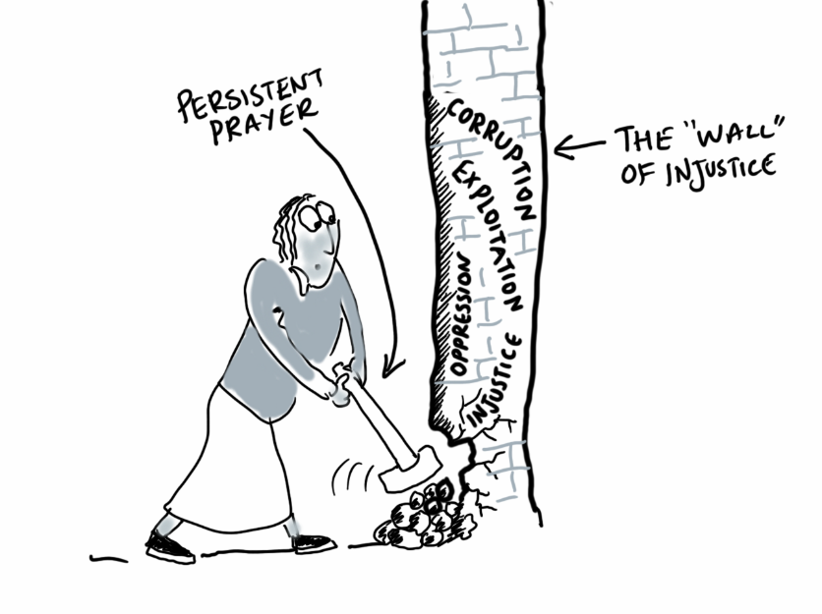
At the beginning of this parable Jesus explicitly states his reason for telling the story: that is, that we should always pray and not give up. As with all his stories, however, there are many facets to explore and a multitude of layers to uncover.

Take some time to reflect on the two versions of the parable and then consider the following thoughts:

The status of a widow in Jewish society was one of powerlessness and fragility.
- For what reason might Jesus have used such a character as an example of persistence in prayer?
- What encouragement to pray can we gain from this character?

This parable is an example of the “how much the more” illustration that Jesus regularly uses in his teaching i.e. if an unjust, flawed character as this judge could be swayed by persistent intercession, how much the more will God, who is perfect, look favourably on our pleas.
- In comparing and contrasting the judge with our perfect Father what do we discover about the character of God and his attitude to our prayers?
- What encouragement to pray can we gain from this contrast?

Jesus’ emphasis on the widow’s persistence in this parable links with his teaching on prayer in Luke 11.
“So I say to you, Ask and keep on asking and it shall be given you; seek and keep on seeking and you shall find; knock and keep on knocking and the door shall be opened to you.
For everyone who asks and keeps on asking receives; and he who seeks and keeps on seeking finds; and to him who knocks and keeps on knocking, the door shall be opened.”
Luke 11:9-10 (Amplified Bible)
- What encouragement to pray can we gain from this teaching?

